MdCourtWatch.com NEWS
THE
VICTIMS
ROUNDTABLE
Mdcoutwatch.com Secretjustice.com Georgemdcermott2014.com Occupythelaw.com
From George E. McDermott 143 N. Huron Drive Forest Heights, MD 20745 Phone 301 996-9577 email @ secretjusticepr@yahoo.com
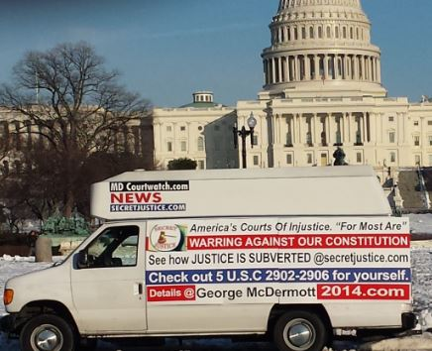
August 1, 2014
Sgt. Nairobi Timberlake
United States Capitol Police
119 P St. NE. Washington DC 20510
by email to Nairobi. Timberlake@uscp.gov

Sgt. Timberlake this is a follow-up to the incident yesterday afternoon at the press accreditation office S 3 20 of the US capital. Where I was there to pick up a copy of the
capital press rules which thanks to you I was able to obtain from the Senate rules committee this is what I was asking for when the incident started.

I apologize for the inconvenience of the officers involved but I now must ask you to provide me with a name of the party making the complaint that necessitated as I counted almost 15 officers being involved not to mention to officers from the office of threat assessment to the US capital.
Because of the severity and the future implications of this incident which may result in the loss of my District of Columbia press credentials if the correct information is not known and not recorded properly. I’ve included basic information showing I report on the victims of our broken judicial system and matters of public interest in public concern to all citizens of our Republican form of government therefore I will be needing the complaint in’s name so I can file a formal request on all records the Capitol police may have on my person both as a reporter and as a private individual under The Privacy Act of 1974, Public Law 93-579,
I would not have to make this request of your office Sgt. if the public servants in the office who witnessed the events and or alleged misconduct on my behalf would have had business cards. To identify themselves as other staffers in the capital are furnished with including yourself and I thank you for furnishing me with your information.
As I stated in the record I had spoken with the gentleman Michael on February 3 or fourth 2013. But since then outside parties have hacked into my computer system deleting large amounts of information which is been reported to the proper authorities and I am waiting for the FBI to respond to my request. A copy is attached for your records.[Att 1-2], as I said in my statement I had just finished video taping and awards ceremony honoring the Hon. Congressman Elijah Cummings. At the national whistleblowers 2014 convention Congressional education panel being held at the Cannon House office building room 340. I’m also providing you with 23 pages of information on myself including evidence on my website that I was acting in the best interest of the citizens of this nation when I requested a copy of the Senate rule.
Respectfully submitted

George Edward McDermott
Att # 1
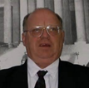
George McDermott for Congress,
Maryland’s 4th Congressional District 2014.
143 North Huron Dr. forest Heights, MD 20745 phone 301-996-9577.
Campaign website George McDermott.com NOW former candidate.

Date: _July 21, 2014
FBI Record/Information Dissemination Section
Attn: FOIPA Request
170 Marcel Drive
Winchester, VA 22602-4843 by USPSCRMRRR # 7010 0290 0000 7534 5379
Dear FOIA Officer: Chief Compliance Officer Patrick Kelley.

The purpose of this letter is to request information pursuant to the freedom of information act ( FOIA). 5 U.S.C section 522 . If the information is not available from your agency, please forward this request to the appropriate agency or advised me of the agency which might have this information.

Please read the attachments and provide me with the following information and provide a copy of the following items which are in the control and custody of this agency

Date range of request: _1/2/2011 through 7/21/2014

Description of Request:
Please search the FBI’s indices to the Central Records System for the information responsive to this request related to: Recently discovered evidence that the FBI has believed to obtained access to my personal computer and most likely obtained a warrant as required under the fourth amendment to monitor my Internet use and personal and business phone calls.

To make myself clear on July 21, 2014 I received an email from an associate Janice Wolk Grenadier with proof that the FBI has hacked her computer and most likely her telephone for reasons unknown. [Att 1] is a request of the clerk of the court for Alexandria Virginia filed into the record July 21, 2014 at 2:47 PM. Containing a total of nine pages requesting information on whether the judges of that court authorized legal wiretaps on my associate and/or myself.

Secondly I am enclosing a 14 page request to the federal election commission office of the Inspector General Lynn a McFarland of February 10, 2014 asking for a investigation into federal campaign-finance fraud and tortious interference with a federal Congressional campaign for Maryland’s fourth congressional district by the named plaintiffs in the above-captioned court case and their agents in Florida. Operating under the alias of Maggie cats/Loretta lax Miller 2016 campaign for US president.
I am asking now for your office to assemble for my inspection and the inspection of my associate Janice Wolk Grenadier. Any and all documents, correspondence , complaints. Workup sheets 522 reports from field agents who have received requests from myself for assistance of other victims and the Baltimore field office, the Annapolis Maryland field office, the Richmond field office, the headquarters of the FBI at 935 Pennsylvania Ave. Washington DC, the Washington DC field office or any correspondence from Washington state FBI representatives employees or assigns regarding George McDermott, Maryland courtwatch.com, secretjustice.com, occupy the law.com. In the files of the FBI. Evidence of numerous filings is available@secretjustice.com where virtually every office of the FBI has prohibited victims of filing complaints against officers and agents of the courts acting outside of their oath of office and the Constitution of the United States.

Also I would like to have a copy of all signed orders from any and all judges and the formal request forms from the FBI required under Justice Department guidelines for wiretaps outlined under. Chapter 9-7.010 ntroduction
This chapter contains Department of Justice policy on the use of electronic surveillance. The Federal electronic surveillance statutes (commonly referred to collectively as "Title III") are codified at 18 U.S.C. § 2510, et seq. Because of the well-recognized intrusive nature of many types of electronic surveillance, especially wiretaps and "bugs," and the Fourth Amendment implications of the government's use of these devices in the course of its investigations, the relevant statutes (and related Department of Justice guidelines) provide restrictions on the use of most electronic surveillance, including the requirement that a high-level Department official specifically approve the use of many of these types of electronic surveillance prior to an Assistant United States Attorney obtaining a court order authorizing interception.
Chapter 7 contains the specific mechanisms, including applicable approval requirements, for the use of wiretaps, "bugs" (oral interception devices), roving taps, video surveillance, and the consensual monitoring of wire or oral communications, as well as emergency interception procedures and restrictions on the disclosure and evidentiary use of information obtained through electronic surveillance. Additional information concerning use of the various types of electronic surveillance is also set forth in the Criminal Resource Manual at 27.
Attorneys in the Criminal Division's Electronic Surveillance Unit of the Office of Enforcement Operations are available to provide assistance concerning both the interpretation of Title III and the review process necessitated thereunder. The procedures are described in the Criminal Resource Manual at 27-37 and 89-92. The Electronic Surveillance Unit has developed a user-friendly DOJNet site that contains training materials and sample Title III documents for review. Interceptions conducted pursuant to the Foreign Intelligence Surveillance Act of 1978, which is codified at 50 U.S.C. § 1801, et seq., are specifically excluded from the coverage of Title III. See 18 U.S.C. § 2511(2)(a)(ii), (2)(e), and (2)(f). [revised July 2012]

I am willing to pay up to [$_$100___ ] for the processing of this request. Please inform me if the estimated fees will exceed this limit before processing my request. However I would like to view the documents at your facility and be able to scan them into a computer as to reduce the cost
I am seeking information for personal use and not for commercial use.
Thank you for your consideration,

Name: _George Edward McDermott
Title (optional): VICTIM AND VICTIMS RIGHTS ADVOCATE
Business (if applicable): _Former candidate for U.S. Congress victim of computer hacker
Street Address: 143 North Huron Dr.
City/State/ZIP Code: Forest Heights, MD 20745
Country (if applicable): Prince George’s County
Telephone (optional): 301-996-9577 home phone and fax 301-839-5816
E-mail (optional): secre justicePR@yahoo.com
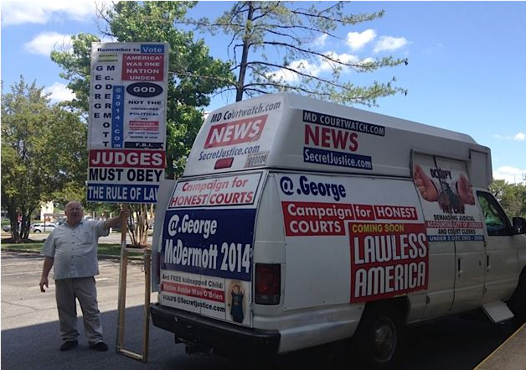


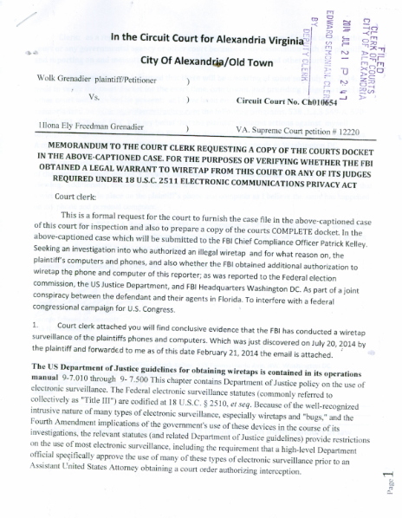

Respectfully submitted
George Edward McDermott
with attachments [ 1 + 2] 23 pages
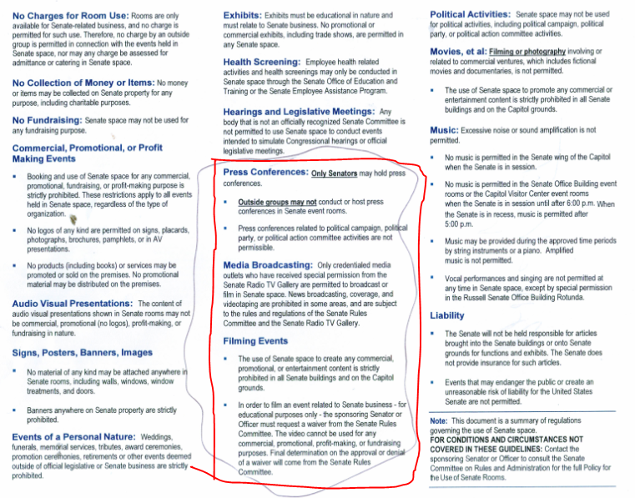

Sgt. Timberlake the following 20 + pages I submit to you as evidence that I was making the request not only for myself but for other participants in the 2014 convention and CONGRESSIONAL Educational panel. Who had been speaking for the last two days at the Cannon House office building room 340.
I'm sorry I cannot produce the letter at this exact time but I promise to follow up the soon as I can get my computer control back but many attendees to the 2013 all us America congressional educational panel have copies of this document if I can't retrieve it from my computer. I cannot stand to have these false allegations placed against me by capital employees and staff members. As I'm sure your reports and those of the threat assessment section of the Will confirm a pop response to my certified mail request as I am entitled to under the Privacy Act of 1974, Public Law 93-579,. Thank you once again your officers and agents acted with the highest standard of conduct to this unfortunate situation and they are to be commended for professionalism.


533 | Interviews with and children's hero Doctor Jim Singer who risk everything to report solid case of child abuse to his superiors and the courts only to be destroyed by the Pennsylvania child protective services agents and their superiors the same parties in the Jerry Sandusky Penn State cover-up . this American hero risk everything to save our children only to betrayed by the Government insiders in the US Justice Department , , the FBI, Health and Human Services. s Ste Government Agents, , Pennsylvania state Atty. Gen all covering up criminal activities by their oh employees. Just like they did in the Penn State matter but Jim Singer will get syndicate and his license restored this is part one of a five part series on CPS FRAUDS STATE COVER UP keep the money tree flowing State Agencie
The Privacy Act of 1974, Public Law 93-579,
V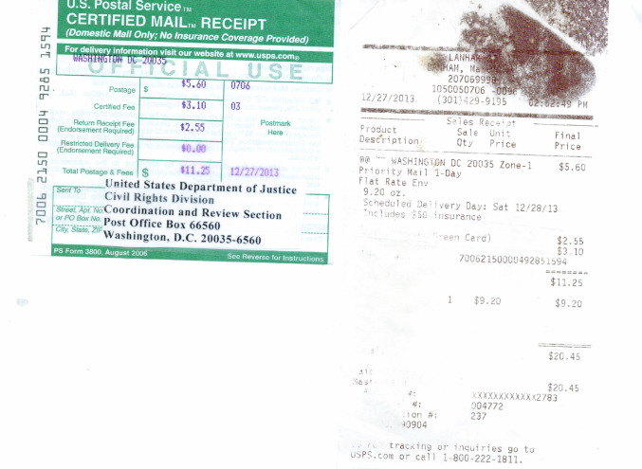

See complaint attached

MdCourtWatch.com NEWS
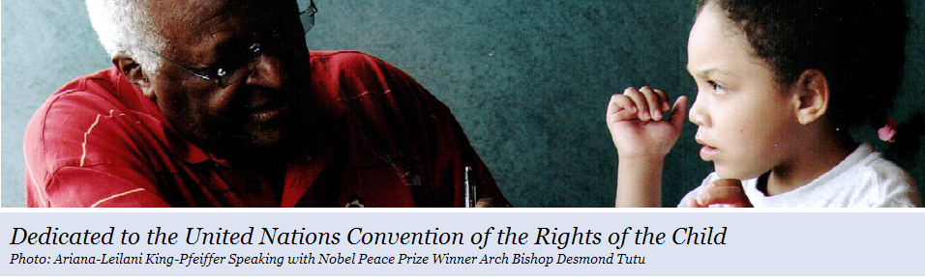
Mdcoutwatch.com secretjustice.com georgemdcermott.com saveme101.com

George E. McDermott
143 N. Huron Drive
THE VICTIMS ROUNDTABLE
Forest Heights, MD 20745
301 996-9577 email @ secretjusticepr@yahoo.com

December 26, 2013

US Department of Justice
950 Pennsylvania Ave.,
NW., Washington, DC 20530
Civil Rights Division, Attn: by certified mail article. # 7006 2150 000492851594
Coordination In Review Section. Return receipt requested

Dear Sir or Mdm.
This Is A Official Complaint Consisted With Your Online Complaint Form.
DOJ form requirements
state your name and address
1 . My name is George McDermott , I live at 143 North Huron Dr. forest Heights, MD 20745 my home number is 301 839-5816, which also acts as a fax. My work number is 301-996-9577. Which I use for all of my media and business calls, is also used as my primary contact for George McDermott for U.S. Congress, Maryland’s Fourth Congressional District 2014. Campaign phone as a Republican candidate.

2.-Persons (s) discriminated against, if different from the above.
a. I am contacting your agency asking for assistance. Today regarding the matter of racial and ethnic discrimination against Asian American citizen Qihui Huang. Who is being victimized and severely discriminated against by Maryland’s seventh judicial circuit court judges. And the United States district court judges acting outside of their oath of office to do financially destroy this citizen.

b. As a reporter and also as a victim of several of the same judge’s involved in this racial and ethnic discrimination, taking place against citizen Qihui Huang. I am also a victim of 20 years of judicial abuse and fraud by many of the same judges in her action. See [Att. 1]. Which have turned me into a victims rights advocate and reporter/court watcher to help protect the rights and liberties of my fellow citizens and their family members. Which I report and make video records of these systems at the following websites. @ Mdcoutwatch.com secretjustice.com georgemdcermott.com saveme101.com and occupy the law.com.

c. This victim can be contacted through her attorney, who I believe is being threatened and intimidated by the court specifically, judge the dishonorable Amy Janel Bragunier, whom I have witnessed in the last several hearings, which are on the court transcripts. That she intends to sanction the plaintiff for allegedly filing frivolous lawsuits, which is an absolute misstatement of the record and I have filed motion papers to that effect with the court prior to commencing this complaint against the same judge who routinely denies due process rights at law to all pro se litigants, including myself, who come before in the court. In direct violation of her oath of office and loyalty to our Constitution.

3. Agency and department or program that discriminated.
a. Prince George’s County Circuit Court Md’s, seventh judicial circuit, Montgomery County Circuit Court Md’s. Maryland Appellate courts. United States District Court’s for Md. United States Court of Appeals for the circuit. All have contributed to the district government toward practices against the citizen in violation of their oath of office and rules of professional conduct in professional responsibility outlined in the Maryland and the U.S. Constitution. Affirmed by the Bill of Rights.

b. All the above courts have for fire failed to provide full fair and honest services in accordance with 5 USC 2902-2906, with the latest discriminatory acts taken place in Charles County Circuit Court before judge which I as a witness in both proceedings, September 25, 2013 and December 19, 2013, can testify to his secret proceedings held in chambers off the record, and to the criminal misconduct of defendants counsel’s fraudulent statements against the plaintiff citizen Qihui Huang. Where the judge openly stated that she would not tolerate the victims claims any further. And would issue orders restraining the victim from ever filing any lawsuit against the defendant in any court anywhere subject to immediately being jailed.

c. The judges of these courts are all guilty of failing to provide honest services. And making false claims and malt false statements in judicial orders and pleadings not supported by the law or the Constitution. Their actions are discriminatory and prohibited under the false claims act. As they waste taxpayers money. To shield corrupt lawyers and fellow members of the American Bar Association appearing before them against unskilled pro se litigants who have been disenfranchised of their rights, liberties and property under color of law, as is in this case. [Att.1]

4a. Non-in employment: treasure complaint concerned discrimination in the delivery of services or in other discriminatory actions of the department or agency and its treatment of you and others.?. If so, please indicate how the basi(s) on which you believe these discriminatory actions were taken (e.g., “African-American” or “Sex: Female.”)

4b. In this particular case, the victim is an Asian American woman pro se litigant citizen Qihui Huang , who was trying to recover damages caused to her by corporate lawyers for Government Agencies and Cyntax Homes. Trading under numerous corporate identities. Who first defrauded the victim. By forcing her to go to settlement on a new home that was uncompleted and in violation of laws outlined under 15 USC 1692. Where they threatened citizen Qihui Huang , if she did not sign the documents and little paper secured by federal loans. They would wager contract and keep her deposit. All court actions from that point forward have been discriminatory against this Asian American citizen, and her family. To protect the criminal misconduct of the government entities and defendant’s lawyers who have never. Produced meaningful discovery, forced pro se litigant to trials and proceedings in violation of her due process rights at law. All the so that the defendants and their agents could profiteer off of their first frauds on the court.
4c. victim is an Asian-American woman with a hearing impairment and a language impairment which the courts are using against her. Additionally, since her first attorney was terminated for nonperformance of proceeding in good faith victim was self represented until the last preceding December 19, 2013 a hearing that I believe is a sham. Due to the earlier vacating of all judgments against the victim by the court recorded. On the court docket which I have enclosed a copy of for your review. [Att. 1].
4.d. As a reporter I have 600 programs. At secret justice.com that chronicled the criminal abuse of our court system against women and minorities/ African-Americans by the courts of Maryland, acting outside of their oath of office and loyalty to the Constitution. Court records will attest to the following that each of these parties have been disenfranchised of their rights and liberties under color of law. By an out-of-control court system that does not respect or honor the Constitution of United States or the victims rights and liberties to appear before them. (1) FEMALE Janice Wolk Grenadier pro se litigant. Victim of corruption in Virginia courts up in and to include Virginia Supreme Court (2) female pro se litigant Dolores O’Brien , Heffernan and her family, including female victim minor child Ashley Mae O’Brien, who has been kidnapped twice by Virginia authorities. Samantha Mahoney female victim of wrongful imprisonment by Arlington County. Female pro se litigant, Lori Saxon and daughter, Jayne victims of judicial abuse, extortion schemes, probate fraud and conspiracy to deny access to courts. Female victim Jean W Mashaud. And bill Gottlieb victims of foreclosure fraud, false imprisonment, conspiracy against rights, and false persecution and prosecution by Calvert County, Maryland public defender/prosecutor’s office. Female victim Sylvia Zaurous of malicious persecution and prosecution and three years false imprisonment in mental institution by Maryland judges and rogue prosecutors committing fraud on the court. Female victim Alice Hanson, Virginia Beach, Virginia victim of malicious persecution and prosecution by authorities. Females African-American Dr. Arial King mother of Arana Leilani king Pfeiffer minor child victims of judicial abuse. Female African-American lawyer. Prince George’s County Maryland Michelle Davies victim of judicial abuse. Female African-American lawyer. Prince George’s County Maryland Rhonda Pentz victim of judicial abuse foreclosure fraud. All the above of victims of a broken court system. It has no respect for the rule of law or victims rights in need of assistance from the judge, US Justice Department. The law clearly states.
A "void" judgment, as we all know, grounds no rights, forms no defense to actions taken thereunder, and is vulnerable to any manner of collateral attack (thus here, by). No statute of limitations or repose runs on its holdings, the matters thought to be settled thereby are not res judicata, and years later, when the memories may have grown dim and rights long been regarded as vested, any disgruntled litigant may reopen old wound and once more probe its depths. And it is then as though trial and adjudication had never been. Fritts v. Krugh, Supreme Court of Michigan, 92 N.W.2d 604, 354 Mich. 97 (10/13/58).

5. What is the most convenient time for us to contact you about this complaint ?.
I can be reached at any time at the above reference numbers. I am also just on average 10 minute drive from your offices at 950 Pennsylvania Ave. and am willing to come forth and make statements under oath as to the misconduct, I have seen in the court proceedings regarding victims proceedings I have been at and witnessed outlined in paragraph 4C., All of which are backed up video evidence which is made available to your office at @ secret justice.com programs one through 557 et el.
6. If we will not be able to reach you directly, you may wish to give us the name and phone number of a person who can tell us how to reach you and to provide information about your complaint.
6a. As I am making this complaint that only about a follow Asian American woman / citizen Qihui Huang. And myself, which all contact information is available at the top of this document, but the victim has recently retained an attorney. Which I believe is also being illegally discriminated against, to represent her interest, contact information. Patricia H lye, at 1 Church St., Suite 801 Rockville, MD 20850 phone contact (301) 444 – 4700 as of November 15, 2013. See [Att. 1].
7 Contact information as above. Listed in paragraph 6a.
8. To the best of your recollection on what dates(s) did the alleged discrimination take place ?.
8a. Earliest date of discrimination. First instance occurred October 6, 2008 October 16, 2008 October 20, 2008 against George McDermott. Victim of judicial abuse by judge Amy Janel Bragunier see Sub attachments and docket # [3].
8b. Most recent date of discrimination. September 25. 2013 and December 19, 2013. Events recorded on the court docket. See. [Att.1] response from intervener/victim. Who must assert for the record. The law does not support the court’s alleged position. The judge had no right to announcing she would find against the victim in respective of what her attorney presents to the court in his court ordered five day response from. Asian American woman / citizen Qihui Huang
A "void" judgment, as we all know, grounds no rights, forms no defense to actions taken thereunder, and is vulnerable to any manner of collateral attack (thus here, by). No statute of limitations or repose runs on its holdings, the matters thought to be settled thereby are not res judicata, and years later, when the memories may have grown dim and rights long been regarded as vested, any disgruntled litigant may reopen old wound and once more probe its depths. And it is then as though trial and adjudication had never been. Fritts v. Krugh, Supreme Court of Michigan, 92 N.W.2d 604, 354 Mich. 97 (10/13/58).

9. The DOJ form. States. Complaints of discrimination must generally be filed within 180 days of the alleged discrimination. But the most recent date of the discrimination, listed above. More than 180 days ago , you may request a waiver of filing requirements. If you wish to request a waiver. Please explain why you waited until now to file your complaint.

9a. I believe if the US Justice Department and FBI were to check its records it would find that I filed a timely complaint for George McDermott victim in 2006. Since I am making this complaint. On behalf of the disenfranchised Asian American woman / citizen Qihui Huang as an outraged citizen, an victims rights advocate without her knowledge. As a victim and a victims rights reporter I believe it’s my duty and responsibility to report of judicial abuse to the proper authorities who have jurisdiction over these matters. Since the last infraction occurred less than 10 days ago I do believe your agency has authority and jurisdiction to investigate this matter. [Att 1]. And no waiver is required.

10. Please explain as clearly as possible what happened, why you believe it happened, and how you were discriminated against. Indicate. Who was involved. Be sure to include how other persons were treated differently from you. (Please use additional sheets if necessary, and attach a copy of the written material pertaining to your case.)

10a. As far as my part of the complaint. Against the dishonorable Amy Janel Bragunier, and off-season seventh judicial circuit of Maryland . The history of mistreatment and fraud by the court officers and this particular officer goes back 20 years, over 110 court cases, at present, [Att 2] approximately 14,000 docket entries chronicling judicial fraud and abuse and cover-up because I was a victim of legal abuse involving another judge in the seventh judicial circuit, Thomas Smith retired Prince George’s County, who along with his in-laws employer Gilbert Saperstein Godfather of the Mafia for Maryland. Committed the first frauds against the court which everyone other court, state and federal have been trying to cover up for 20 years. The record is to numerous, but the latest filing with the Baltimore city Sheriff’s Department. For your request should give you insight as to the power of this Mafia leader over the Maryland court system. Once again, all judgments entered against myself and the overturning of all three jury verdicts by judges in my and my family’s favor are void and have no legal force and effect, “A judgment rendered in violation of due process is void in the rendering State and is not entitled to full faith and credit elsewhere. Pennoyer v. Neff, 95 U.S. 714, 732-733 (1878).” [World-Wide Volkwagen Corp. v. Woodson, 444 U.S. 286 (1980)] [Att.2]

10b. As far as the victim goes a follow Asian American woman / citizen Qihui Huang. a follow Asian American woman / citizen Qihui Huang. I believe is my absolute duty and responsibility as a citizen of these United States. To report alleged criminal activity involving fraud on the court’s and bring it to the attention of the appropriate legal authority. Which in this case would be. US Department of Justice and this office. Each and every time I see a new crime happening. In the instance case I was a witness at two proceedings which I watched lying lawyers commit fraud on the court openly and I watched a judicial officer in my opinion, frustrate justice and openly denied the plaintiff and her attorney. A full fair and honest proceeding, thereby failure to provide honest services. [Att 1-2] compounded by the court’s pronouncement that it plans to sanction the plaintiff, irrespective of any arguments, approximately $100,000 in legal fees to a bunch of gangster lawyers working in consort one with another, to bring discredit upon America’s court system and line their pockets with her ill-gotten gains. The history of judicial terrorism against myself and other victims, which I have attempted on numerous occasions to bring to the attention of the Justice Department and the FBI without success is in conflict with DOJ’s rules and regulations so I will simply defer to the records in the court documents, motions and pleadings filed in the courts referenced above, which are available on Maryland judiciary case search.com to ascertain the extent of this conspiracy to two deprived all pro se litigants of their rights, liberties and property under color of law and authority.
10c. This Complaint, Only To Be Illegally Thrown In A Trashcan Or For Hopefully Legally Acted Upon .
In Any Event This Citizen Is Done His Job Notifying The Proper legal Authorities.
From DOJ’s own UNCLASSIFIED - FOR OFFICIAL USE 'ONLY
Domestic Investigations and Operations Guide/rules
3. (U) Core Values, Roles, and Responsibilities
3.1. (U) The FBI's Core Values
(U) The FBI's values do not exhaust the many goals we wish to achieve, but they capsulate them as well as can be. done in a few words. The FBI's core values must be fully understood, practiced, shared, vigorously defended, and preserved. The values are:
- (U) Rigorous obedience to the Constitution of the United States
- (U) Respect for the dignity of all those we protect
- (U) Compassion
- (U) Fairness
- (U) Uncompromising personal integrity and institutional integrity
- (U) Accountability by accepting responsibility for our actions and decisions and their consequences
- (U) Leadership, by example, both,personal and professional
(U) By observing these core values, we achieve a high level of excellence in performing the FBI's-national security and criminal investigative functions as well as the trust of the American people. Rigorous obedience to constitutional principles ensures that individually and institutionally our adherence to constitutional guarantees is more important than the,outcome of any single interview, search for evidence, or investigation. Respect for the dignity of all reminds us to wield law enforcement powers with restraint. Fairness and compassion. ensure that we treat everyone with the highest regard for constitutional, civil, and human rights. Personal and institutional integrity reinforce each other and are owed to our Nation in'exchange for the sacred trust and great authority conferred upon us.
(U) We who enforce the law must not merely obey it. We have an obligation to set a moral example that those whom we protect can follow. Because the FBI's success in accomplishing its Mission is directly related to the support and cooperation of those we protect, these core values are the fiber that holds together the vitality of our institution.
(U) Compliance
(U) All FBI personnel must fully comply with all laws, rules, and regulations governing FBI investigations, operations, programs and activities, including those set forth in the AGG-Dom. We cannot and do not countenance disregard for the law for the sake of expediency in anything we do. The FBI expects its personnel to ascertain the laws and regulations that govern the activities in which they engagd, to acquire sufficient knowledge of those laws, rules, and. regulations to understand their requirements and to conform their professional and personal conduct accordingly. Under no circumstances will expediency justify disregard for the law. Further, the FBI requires its employees to report to proper authority any known or suspected failures to adhere to the law, rules or regulations by themselves or others. Information for reporting such violations is available from the Office of Integrity and Compliance (OIC).
UNCLASSIFIED - FOR OFFICIAL USE ONLY
Domestic Investigations and Operations Guide
FBI policy must be consistent with Constitutional, legal and regulatory requirements. Additionally, the FBI must provide sufficient training to affected personnel and ensure that appropriate oversight monitoring mechanisms are in place. Fortunately, this is untrue statement disproven by court records
11. The laws reinforce prohibit sip units of the Department of Justice from intimidating or retaliating against anyone because he or she has either taking action, or participated in an action to secure the rights protected by these laws. If you believe you have been retaliated against (separate form of discrimination alleged in # 10 ) please explain circumstances below. Please be sure to explain what actions you took which you believe were the basis for the alleged retaliation.
11a. Once again I will defer to the court records in the Supreme Court of the United States, case # 10 – 10236. As a basis for my complaint of failure to provide honest services, obstruction of justice, forgery of court documents, conspiracy to defraud, foreclosure fraud and bank fraud. In my personal case history.
11b. In the history of every other victim listed. In paragraph 4d. The courts have been ignored the rights and liberties of all of these victims, when brought to the attention of the FBI and Justice Department, we encountered lock doors , and no axis to the alleged Government agents and their employees being paid to protect our rights and liberties . Government agents disguised as security simply refusing to allow citizens/victims entry into there buildings. A complete denial Of pro se litigant/victims of legal and civil rights and blatant discrimination, Government agents and agencies insiders and employees conspiring one with another cover-up any and all allegations criminal abuse of the court system by court insiders. Who fabricate an issue, falsified Illegal judgments judgment orders to be entered against victims, in many cases , victims are falsely imprisoned denied access to courts of law and competent lawyers and forced to take incompetent public defenders. Crimes against these victims range from kidnapping, extortion, denial of due process rights at law, false imprisonment, theft of properties, falsification of court documents against victims. False judgment entered against victims all to protect a system of broken justice. All chronicled in court documents and on video. @ secretjustice.com where approximately 600 programs on victims of judicial and legal abuse are available for this agency to review. SEE [Att. 1-3]
____________________________________________________________________________________
12. Please list below any persons (witnesses, fellow employees, supervisors, or others). If no, whom we may contact for additional information to support or clarify your complaint.
12a. Due to the amount of victims. I know I can only list a few numbers they can list thousands of others
# | Name | Type of victim | Phoe | Cell
1 | Janice Grenadier | Victim of court fraud. Failure to provide to honest services, obstruction of justice plus, foreclosure fraud | 202-368-7178  Virginia | 202-368-7178
2 | Jean W Mashhad | Victim of court fraud. Failure to provide to honest services plus, obstruction of justice + foreclosure fraud & false imprisonment & malicious persecution | 301-882-7543  Maryland | 410-231-1333
3 | Rabbi John Noonan | Victim of court fraud. Failure to provide to honest services plus, obstruction of justice + foreclosure fraud & false imprisonment & malicious persecution | Maryland | 443-409-1376
4. | Bruce Gambill | Victim of court fraud. Failure to provide to honest services plus, obstruction of justice + foreclosure fraud & false statements & malicious persecution | Washington state | 253-212-7242
5 | Lori Saxon | Victim of court fraud. Failure to provide to honest services plus, obstruction of justice + foreclosure fraud & false statements & malicious persecution | Washington, DC.
6 | Sharon V Galloway | Victim of court fraud. Failure to provide to honest services plus, obstruction of justice + poisoning, fraud & false statements & malicious persecution | Maryland | 410-833-5588
7 | James Manship | Victim of court fraud. Failure to provide to honest services plus, obstruction of justice + prosecutors fraud & false statements & malicious persecution | Virginia | 703-672-1776
8 | Duane Davis candidate Maryland Lt. Gov. 2014 | Victim of court fraud. Failure to provide to honest services plus, obstruction of justice + false imprisonment & false statements & malicious persecution | Baltimore, Maryland | 433-831-1180
9 | Brian Beats candidate Maryland Gov. 2014 | Victim of court fraud. Failure to provide to honest services plus, obstruction of justice + poisoning, fraud & false statements & malicious persecution | Baltimore, Maryland | 410-931-4423
10 | Donnie Thole | Victim of court fraud. Failure to provide to honest services plus, obstruction of justice + foreclosure fraud & false statements & malicious persecution | Maryland | 301-275-8326
11 | Glendora at YouTube | Victim of court fraud. Failure to provide to honest services plus, obstruction of justice + foreclosure fraud & false statements & malicious persecution | New York State | 518.610 5810
11 | Sylvia Houzouris | Victim of court fraud. Failure to provide to honest services plus, obstruction of justice + false imprisonment & false statements & malicious persecution | Maryland Harford County | 410-420-1095
12 | Alice Hanson | Victim of court fraud. Failure to provide to honest services plus, obstruction of justice + foreclosure fraud & false statements & malicious persecution | Virginia Beach, Virginia | 757-729-4461
13 | Dick Wolfrey | Victim of court fraud. Failure to provide to honest services plus, obstruction of justice + foreclosure fraud & false statements & malicious persecution | Now in Atlanta, Georgia | 678685 4508
14 | Ashley Mae O’Brien | Kidnapped secret location, Virginia. Child protective services kidnappers | Somewhere in Virginia | Unknown
15 | Elizabeth Pawlak | Victim of court fraud. Failure to provide to honest services plus, obstruction of justice + foreclosure fraud & false statements & malicious persecution | Southern Maryland | 954-821-6878
16 | Todd Wetzelberger | Victim of court fraud. Failure to provide to honest services plus, obstruction of justice + foreclosure fraud & false statements & malicious persecution | Baltimore, Maryland region | 410-916-8863
17 | Mark Tomy | Victim of court fraud. Failure to provide to honest services plus, obstruction of justice + false imprisonment & false statements & malicious persecution | Baltimore County, MD | 443-622-1186
18 | Sam Brenner | Victim of court fraud. Failure to provide to honest services plus, obstruction of justice + foreclosure fraud & false statements & malicious persecution | Cecil County, Maryland | 717-327-7474
19 | James Thomas Armour | Victim of court fraud. Failure to provide to honest services plus, obstruction of justice + foreclosure fraud & false statements & malicious persecution | Cecil County, Maryland | 443-309-2727
20 | Douglas Willard | Victim of court fraud. Failure to provide to honest services plus, obstruction of justice + foreclosure fraud & false statements & malicious persecution | Cecil County, MD | 403-907-0217
21 | Mark young | Victim of court fraud. Failure to provide to honest services plus, obstruction of justice & CPS fraud | Alexandria, Virginia | 703-798-759
22 | Mary Wagner | Victim of court fraud. Failure to provide to honest services plus, obstruction of justice & false statements & malicious persecution | Baltimore, Glen Bernie | 410-760-2161
23 | Samantha Mahoney  sister of kidnapped Ashley Mae O’Brien | Victim of court fraud. Failure to provide to honest services plus, obstruction of justice & false statements & malicious persecution & false imprisonment after being beaten by Sheriff’s deputies | Address unknown. Montgomery County | Phone contact unknown
24 | Ariana king Pfeiffer | Alleged victim of child trafficking. And cover-up by government agents. | Mother’s number | 202-470-0193
13. Do you have any other information that you think is relevant to our investigation of your allegations?
13a. Each of the parties named above have submitted evidence to me that is in the court records that would lead a person of reason and knowledge to believe they have been robbed of their rights, liberties and property in most cases by, judicial indifference to preventing fraud and corruption within their courts and the courts acting outside of their oath of office and loyalty to the respective constitutions of their states for this nation as outlined under 5 USC 2902-2906.
Their stories are available@secretjustice.com programs 1-576, many of them having multiple segments. All doing with a common theme their all pro se litigants, 90% women, and all have been to vested of their rights and liberties. Based on their race, gender or the fact that they dare to walk into a court and try to represent themselves. Which is a fundamental right under 28 USC 1654.

28 USC § 1654 - Appearance personally or by counsel Current through Pub. L. 113-31. (See Public Laws for the current Congress.)In all courts of the United States the parties may plead and conduct their own cases personally or by counsel as, by the rules of such courts, respectively, are permitted to manage and conduct causes therein.
LII has no control over and does not endorse any external Internet site that contains links to or references LII.

14. What remedy are you seeking for the alleged discrimination?

14a. That the Justice Department as the head of our court system investigate its employees from Supreme Court justice Roberts down to the lowliest bankruptcy judge. And make sure that victims rights are restored and that all parties who have been disenfranchised of their do process rights at law with sham forged fraudulent court orders. Be given the right to relitigate without any additional cost their claims of relief and a fair and unbiased judicial proceeding with judges who respect the rule of law and the Constitution. The COMPLAINTENT. in this complaint is not a vexatious litigant, but is a disenfranchised citizens/victim of our broken court system.

14b. That the Justice Department and the FBI investigate what is now economic and judicial terrorism taking place in our courts of law, that has the effect of destroying the fabric of our nation and undermining the integrity of our judicial system. So that lying lawyers and fellow bar members of judges can get away with, fraud on the court, obstruction of justice, failure to provide honest and true services, making false statements as to material facts in open court, without any consequence whatsoever. Wasting of government and state resources to facilitate this fraud by judges and insiders courts who failed to abide by their oath of office and the Constitution and rule of law there in which they have sworn loyalty to.

14c. That the FBI and Justice Department stop, locking the citizens out of our buildings and offices from which these agencies work. And denying our citizens full legal access to those offices who they can reasonably rely on that will allow our citizens to take appropriate action in filing criminal complaints against those who work with in the system to defeat justice and assist the criminal element, which has taken over our court system and denied access to the courts of law in conflict with article’sb6tvrd x 17-19 of the Maryland declaration of rights and the U.S. Constitution Bill of Rights.
Art. 17. That retrospective Laws, punishing acts committed before the existence of such Laws, and by them only declared criminal are oppressive, unjust and incompatible with liberty; wherefore, no ex post facto Law ought to be made; nor any retrospective oath or restriction be imposed, or required.
Art. 18. That no Law to attaint particular persons of treason or felony, ought to be made in any case, or at any time, hereafter.
Art. 19. That every man, for any injury done to him in his person or property, ought to have remedy by the course of the Law of the Land, and ought to have justice and right, freely without sale, fully without any denial, and speedily without delay, according to the Law of the Land.

15. Have you (or the person discriminated against) filed the same or any other complaints with
other offices of the Department of Justice (including the Office of Justice Programs, Federal
Bureau of Investigation, etc.)?
Yes X No
15a. As a reporter I have filed several request for assistance from the DOJ, FBI. With no valid responses do to unsigned form letters that are not in compliance with the departmental guidelines. Even when filing FOIA request. For public documents such as [Att 3]. So far there have been no legal responses. As for whether other parties have filed. I am unaware and have no knowledge or have I seen any filings. And complaints responses keep coming back without complaint numbers. If there is a response at all
15b. I will defer to the record at the US Supreme Court case number # 10-10236. The court denied certiorari for want of jurisdiction because lower court orders were never signed as required by law.
A void judgment is one which, from its inception, is and forever continues to be absolutely null, without legal efficacy, ineffectual to bind the parties or to support a right, of no legal force and effect whatever, and incapable of enforcement in any manner or to any degree. Loyd v. Director, Dept. of Public Safety, 480 So.2d 577 (Ala.Civ.App. 1985). A judgment shown by evidence to be invalid for want of jurisdiction is a void judgment or at all events has all attributes of a void judgment, City of Los Angeles v. Morgan, 234 P.2d 319 (Cal.App. 2 Dist. 1951).

16. Have you filed or do you intend to file a charge or complaint concerning the matters raised in this complaint with any of the following?
16a. Yes, I plan to forward a copy of this complaint to the Maryland bar Council, and Maryland commission on judicial disabilities. As stated in [Att-1] though it is a waste of time because neither one of these agencies act in conformity with the rules and regulations to protect the public from rogue judges and lying lawyers pursuing Walmart litigation strategies against victims and pro se litigants in violation of their oath of office.
17. If you have already filed a charge or complaint with an agency indicated in #16, above,please provide the following information (attach additional pages if necessary):
17a. Numerous complaints of been filed in the matter of record in the United States, archives, both in Maryland and in Philadelphia, Pennsylvania, regarding judicial misconduct, fraud on the court, and obstruction of justice. By judges and court insiders. The first case was opposition to illegal dismissal of bankruptcy case involving the Sapperstein crime syndicates theft of applicants businesses with the help of Maryland judges. Case numbers U.S. Bankruptcy Court 88 – 42746 PM, chapter 11. US District Court Md.# 1:95-CV-03904-MJG. From the first fraud on the court by judges and court insiders.There now are possibly 110 related cases containing 14,000 pleadings. All laid out for the United States Supreme Court in case 10-19236.Which the agency can look up for itself. All involving courts covering up of illegal Walmart litigation, by court insiders and I guess start Mafia leaders, their attorneys, and their judges.
17b. In regards to the main complaint I am making on regarding the matter of disenfranchised Asian American citizen Qihui Huang, many of the same judges have worked against her civil rights and legal rights in the Charles County Md. court system. Maryland appellate court system, United States District Court for Maryland, United States, four circuit Court of Appeals, the injustices can be tracked through the 14 court cases victim has had to endure since the first fraud on her person by the court and court insiders. Conspiring to defeat victims rights under the U.S. Constitution codified in title 15 of the truth in lending act, the fair debt collection practices act, and title 42, civil liberties protections regarding deprivation of civil rights under color of law and authority.
18. While it is not necessary for you to know about aid that the agency or institution you are
filing against receives from the Federal government, if you know of any Department of Justice
funds or assistance received by the program or department in which the alleged discrimination
occurred, please provide that information below.

18a. All agencies involved are supported in whole or in part by the budget of the United States of America and state budgets. Many of these agencies are directly funded by the DOJ’s budget as are their employees and assigns, as well as subcontractors. In addition, all the agencies involved have an absolute legal obligation to prevent the waste of resources and fraud within the system. As outlined in paragraph 10c. Known as THIS AGENCIES / DOJ’s own UNCLASSIFIED Operations Manual Purportedly - FOR OFFICIAL USE 'ONLY Domestic Investigations and Operations Guide/rules 3. (U) Core Values, Roles, and Responsibilities 3.1. (U) The FBI's Core Values. As the best evidence of agencies purpose.

[Att.1] Intervenors motion to Charles County Circuit Court. Regarding Asian American citizen Qihui Huang,
[Att. 2] FOIA request to the Baltimore city Sheriff. Regarding fugitive from justice Gilbert Sapperstein.
A.k.A. Maryland’s Mafia kingpin leader/Godfather of the Maryland Mafia./Court insider-corrupter
[Att. 3] US District Court for Maryland motion papers related to first bankruptcy fraud reported to the FBI, US Justice Department, international authorities because of money laundering and court fraud. Which now can be chronicled in 110 Related Court cases 14,000, docket entries. And 600 videos and secret justice.com and MarylandCorruption.com the Sapperstein crime syndicates history and background.

19.* We cannot accept a complaint if it has not been signed. Please sign and date this
complaint form below.

Submitted by US mail December 27, 2013 ___________________________________
Attested In Notarized For The Record By George Edward Mcdermott
Victim And Victims Rights Advocate
143 North Huron Dr.
Forest Heights, MD 20745
301-996-9577

Please feel free to add additional sheets to explain the present situation to us.
We will need your consent to disclose your name, if necessary, in the course of any investigation.
Therefore, we will need a signed Consent Form from you. (If you are filing this complaint for a
person whom you allege has been discriminated against, we will in most instances need a signed
Consent Form from that person.) See the "Notice about Investigatory Uses of Personal
Information" for information about the Consent Form. Please mail the completed, signed
Discrimination Complaint Form and the signed Consent Form (please make one copy of each for
your records) to:

In the belief that a picture is worth 1000 words I will not take up the agency’s time in identifying each of the victims . Their stories are on the Internet. At secretjustice.com here’s a brief preview.







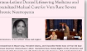


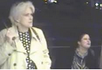

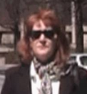






United States Department of Justice
Civil Rights Division
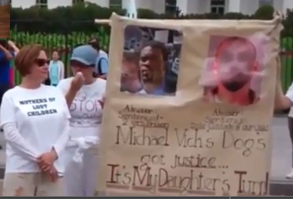
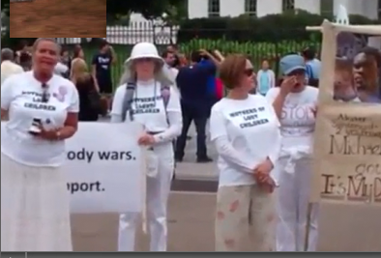



Coordination and Review Section
Post Office Box 66560
Washington, D.C. 20035-6560
(202) 307-2222
TDD (202) 307-2678



