George Edward McDermott
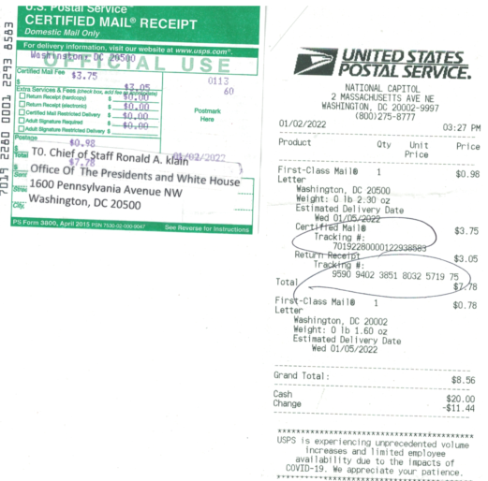
143 N. Huron Dr., Forest Heights
MD 20745 Phone (30) 1-996-9577
Email George McDermott 2018 Gmail.com
website site at George McDermott
January 2, 2022
T0. Chief of Staff Ronald A. klain
Office Of The Presidents and White House
1600 Pennsylvania Avenue NW
Washington, DC 20500 by USPS U.S.P.S. Certifyed mail article
#-7019- 2280-0001-2293- 8583

Dear Chief of Staff Ronald A. klain
I George McDermott am NOW forced to contact your office of and that of our current president, Joseph Biden under the no Fear Act alerting the president as the current CEO of are NOW corporate United States of American as designated under Title 22 USC (Foreign Relations and Intercourse) Chapter 11 identifies all public officials as foreign agents.Chapter 11 identifies all public officials as foreign agents. Title 28 USC 3002 Section 15A states that the United States is a Federal Corporation and not a Government, including the Judiciary Procedural Section. And due to modifications where in our Constitution appears to have been modified clandestinely and STATUTES REPLACED WITH INTERNATIONAL LAW . Beginning in
CIRCA 1933 and memorialized December 9th 1945 published as the International Organization Immunities Act. Which allegedly Relinquished every public office of the United States to the United Nations. See source information at http://avalon.law.yale.edu/20th_century/decad034.asp. And
http://www.law.cornell.edu/uscode/html/uscode22/usc_sec_22_00000288—-000-notes.html.
1, Chief of Staff klain attached you will find a motion paper filed with the US Tax Court 12/31/2021 notifying the court and its officers, agents and assigns that the citizen would be filing a commercial lien against the corporation operating as the United States Government and its subsidiary corporations/officers, For their Violations of oath of office.

2. Chief of Staff klain as I have stated in my filing the office of the president would be notified. Therefore, I am sending this correspondence by certified USPS mail service to your attention or submittal to our president Joseph Biden as the chief elected official of the corporation operating as the United States of America as published under US code reference Title 28 USC 3002 Section 15A , Sir I have before doing this court records will show as well as 500 video posted@secretjustice.com will show that I have petitioned every office of the corporate government to validate the location, the house and Senate bill numbers, the house and Senate passed resolutions and any proofs that the former presidents of the United States and Congress authorized the government of the people by the people and for the people the abolished and taken over by what now appears to be a corporate entity as published under Title 28 USC 3002 Section 15A.
3. Chief of Staff klain and court records attesting to my efforts in an attempt to avoid the having to file a commercial lien against my government are now contained in the over 14,000 docket entries in the state of Maryland District Court, Circuit Court, Courts of Appeals, United States District courts within Maryland, the District of Columbia, and the Commonwealth of Virginia, as well as. There courts of appeal, including the United States Ct. of Federal claims and Appellate Division of the court of federal claims yet not one of these courts or their officers or provide required proof of legal standing, signed oath of office, and most importantly the house and Senate bill numbers the legislative history and where a citizen may obtain these records which must be made available through our national archivist office.
4. Again Chief of Staff klain surely your office. Now that it is been put on notice should easily be able to. Furnish the citizen with the information in an official form Too prove or disprove whether or not the national archivist’s have preserved under Title 22 USC (Foreign Relations and Intercourse) Chapter 11 identifies all public officials as foreign agents. These crucial vital documents abolishing our organic Constitution and rule of law

5. In closing, if you would be so kind to please furnish this disenfranchised citizen with the following it would be greatly appreciated. And the corresponding location numbers
within the national archives and records administration Management by the Archivist of the United States (44 U.S.C. Chapter 29) §§ 2902 through 2911 ©(3) and while you’re at it. If you could possibly look into why the previous Secretary of State office of Public information as well as all the courts above have refused to produce any evidence of legal authority where they now dismiss 99.9% of all pro se litigant cases brought to the courts with only unsigned orders.
6. Again Chief of Staff klain I thank you for it. Time and attention in this matter and sincerely hope that you will forward my attachment and motion paper filed in US Tax Court to my president Joseph Biden, in his capacity as CEO of the alleged Corporate Government and I was shocked to see that the president’s press secretary announcement of 01/01/2022 regarding tax evasion by the billionaires being exposed for exploiting the US tax code of whistleblowers case. I am involved in and Tax Court is also identified billions upon billions of tax evasion by federal banks and their insider attorneys/accountants, eye contact information is listed above I will await your response. God bless and have a good day and remember too honor and defend our Constitution/rule of law.
Respectfully submitted

George Edward McDermott
Attachments in support of request the office of the President of the United States, Inc.
A. Filing with United States Tax Court Washington DC 12/31/2021 9 pages.
Oath Of Office Of Government Employees/Executives
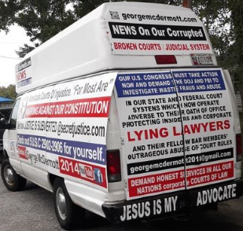
Note Which word in the oath of office requires the president to enforce all laws?
Take Care Clause The president must "take care that the laws be faithfully executed." This clause in the Constitution imposes a duty on the president to enforce the laws of the United States and is called the Take Care Clause, also known as the Faithful Execution Clause or Faithfully Executed Clause.

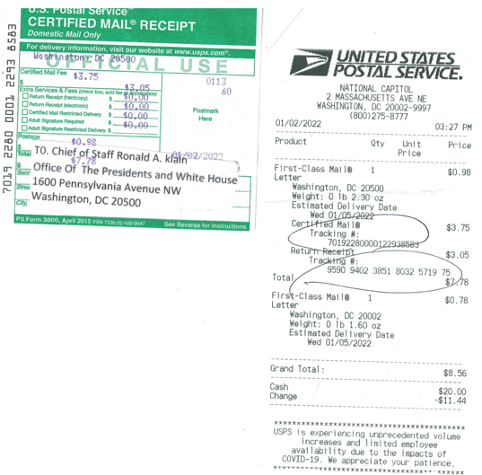
Big question who at the White House removed address from green card official US posted office document and why no signatures of receiving party
Green card returned January 22, 2022 without receiving signature and someone removed the label that was pasted on look closely at the area above barcode this is mail fraud and will be reported to the US postal service inspectors office
