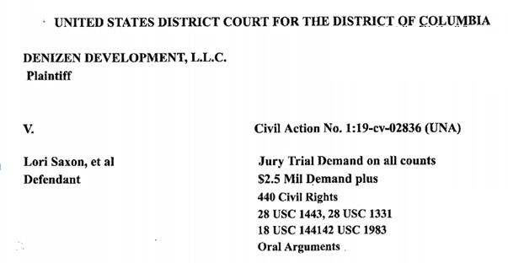
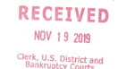
________________________________________________________________________________________
MOTION TO INTERVENE TO PREVENT A MISCARRIAGE OF JUSTICE AND AT REQUEST OF THE PLAINTIFF PURSUANT TO FRCP RULE 24 AND TO PRESENT EVIDENCE OF PAST WRONGFUL MISCONDUCT ON PART OF THE DEFENDANTS MEMORIALIZED IN 113 VIDEOS SUPPORTING PLAINTIFF’S CLAIMS OF RELIEF COURT IS ASKED TO TAKE JUDICIAL NOTICE UNDER FRE RULE 201 & U.S. CONSTITUTION ART 6 SEC. 1, 2, 3, +
5 USC U.S.C. 3331, 3333. & 7311

` Comes now George McDermott citizen of the United States and reporter for Maryland Court Watch NEWS at the request of the defendant filing a motion to intervene to prevent a miscarriage of Justice in this court were all of defendants previous actions were dismissed with forged documents falsified court records and illegal use of alleged per curiam unsigned orders meant to deceive the defendant under false pretenses with criminal intent by named and unidentified court officers and their alleged agents denying defendant’s rightful access to this court through Star chamber proceedings as memorialized @ secretjustice.com. Evidencing a pattern and practice of this court’s unconstitutional denying all pro se litigants their day in court and right to fair honest services while at the same time rewarding lying lawyers using false fabricated court charging documents, unsigned/unverifiable court orders, issued under color of law while abandoning this court’s oath of office
The clean hands doctrine is a rule of law that someone bringing a lawsuit or motion and asking the court for equitable relief must be innocent of wrongdoing or unfair conduct relating to the subject matter of his/her claim. It is an affirmative defense that the defendant may claim the plaintiff has "unclean hands".
1. Intervener having received by email a copy of the alleged order denying defendant’s relief to have the case removed from DC Superior Court to this Federal Court and a copy of the defendant/petitioner’s motion for reconsideration by the full court of this court’s latest order [E – 1] wherein once again it appears that the court refuses to allow pro se litigants cases to move forward giving preference to fellow disloyal judicial officers betraying their oath of office and The American Bar Association’s criminal monopoly covering up frauds and treason against our Constitution and rule of law latest motion paper filed clerk only filed 13 of 63 pages why
Which will verify that the Intervener has appeared in court over 50 times defending her constitutional rights and liberties each time denied by fictitious unsigned order of the court.
2. Intervener currently has 1400 + postings @secretjustice.com open of which 70+ video chronicling the horrendous treatment by the courts against the named defendant. While at the same time plaintiffs and their agents and allege court officers are covering up multistate criminal misconduct of their fellow bar members in violation of their oath of office and disobedience to our Constitution and rule of law all. See Title V 5 U.S.C. 2902 through 2906. [E – 2].plaintiffs should be counted as enemy combatants of our Constitution as defined under title 18 USC 2382…
3. Additionally intervener is fully aware of the inappropriate actions of this court and of this judge having had to contact the US Department of Justice office of The Inspector General criminal investigations division the October 24, 2019 as this court and judge has refused to produce copies of their oath of office and validity of unsigned orders both in intervener’s cases before this court case #’s 1:98 – CV – 1235 TPJ, and one: – CV – 532 – APM, which over 20 years intervener has never had a verified order from this court or any other Federal Ct., the Inspector General office has now forwarded this request to the Administrative Offices Of The US Court System 1 Columbus Cir. NE. Washington DC 20002. [E – 3] as this court fully aware intervener has also prepared request for each and every member the Senate and House judiciary committee to look into the matter of these unsigned orders which are in nonconformity with the statute law of this nation.
4. Intervener has notified this court in good faith and in support of the defendant who is been robbed of $2 million of real property on top of past horrific events this court is fully aware of in DC Superior Court’s where they have covered up the murder defendant’s father-in-law and theft of her and theft of daughters grandfathers rightful inheritance by her father who appears to be acting as a foreign agent for the Russian government and political action committees subverting our election/our rule of law as has been memorialized in video after video. The Justice Department the FBI in this court had a duty to prevent and failed to do so for these reasons intervener must take action on his own to preserve and protect our Constitution from the treasonous misconduct of this court officers and agents destined to undermine the credibility of our legal system with forged unsigned documents, withholding oath of office, and noncompliance with statute law.
"Color of Law" " means "The appearance or semblance, without the substance, of legal right. Misuse of power, possessed by virtue of state law and made possible only because “wrongdoer is clothed with authority of state is action taken under 'color of law.'".
Atkins v. Lanning. D.C.OkI., 415 F. Supp. 186, 188.. "Colour of Law Mere semblance of a legal right. An action done under colour of law is one done with the apparent authority of law but actually in contravention of law." Barron's Dictionary of Canada Law, Sixth Edition, page 51.

In conclusion intervener respectfully request this court is grant the defendant’s motion for reconsideration by the full court as it is in the best interest of justice and also to bring the plaintiffs wrongful misconduct to the attention of this court for abuse of court rules and conspiracy to steal and abscond with millions of dollars of the defendants property with forged documents.
Respectfully submitted
George McDermott INTERVENER NEXT FRIEND OF THE COURT
Certificate of service I George McDermott certify that a true and correct copy of this motion to intervene was mailed first-class USPS postage-paid this 11/19/2019 to the following parties by____________________
Stephen oh Hessler C/O Offit Kurman and Lori Saxon
1313 F St., Suite 500 N.W. 937 in Street NW. Washington DC 20001
Washington DC 20005

ATTACHMENTS IN SUPPORT OF MOTION TO INTERVENE
E – # | scription of documents submitted for the record | date | page #
E – 1 | Defendants motion for reconsideration by full-court | 11/14/2019 | page #4
E-2a | Reply US DOJ – OIG’s office criminal investigations | 11/5/2019 | Page #5
E – 2 | Maryland court watch news secret justice.com 70+ videos of mistreatment by courts of the defendants legal and civil rights | 11/11/09/2019 | Page #6
E – 3 | Intervenors case and this court awaiting review by a panel based on forged unauthorized dismissal order | 10/30/2019 | Page #7
E – 4 | memorandum of law challenging the jurisdiction of the court in the defendants case and appellant case |  | Page #8

- Him him him him him him him him him him him him him your lawyers therefore you will what you motion to suspend appeals overq laws on say something about that but he said I thought involvement of the ball the thought not forget about I hundred percent Sherry: you what you need to find out tomorrow for everything the thing is your system which shocked out of control is deficient be heard together statement the case maybe they’ll drop the state as a friend of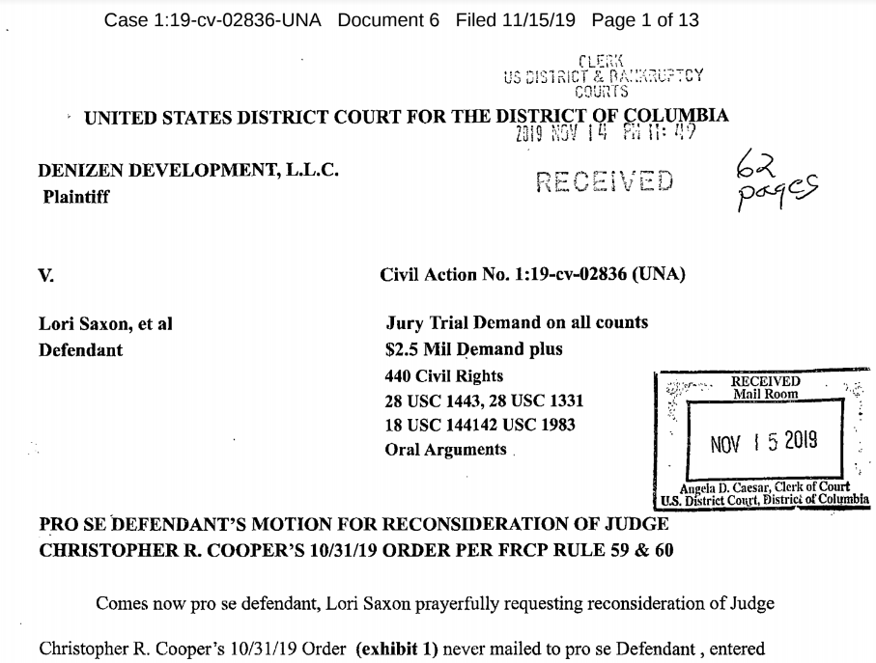
Racketeer Influenced and Corrupt Organizations Act (RICO) Recent Supreme Court Decisions Alice F. Paylor Rosen, Rosen & Hagood, LLC 134 Meeting Street Charleston, SC 29401 (843) 577-6726 I. Cedric Kushner Promotions v. King, 533 U.S. 158, 121 S. Ct 2087 (2001)
A. Last year, in an important case involving RICO statutory interpretation, the Supreme Court, with Justice Breyer delivering the majority opinion, held that a president and sole shareholder of a corporation was a “person” distinct from the corporate enterprise and subject to RICO liability. This case is Cedric Kushner Promotions v. King, 533 U.S. 158, 121 S. Ct. 2087 (2001).

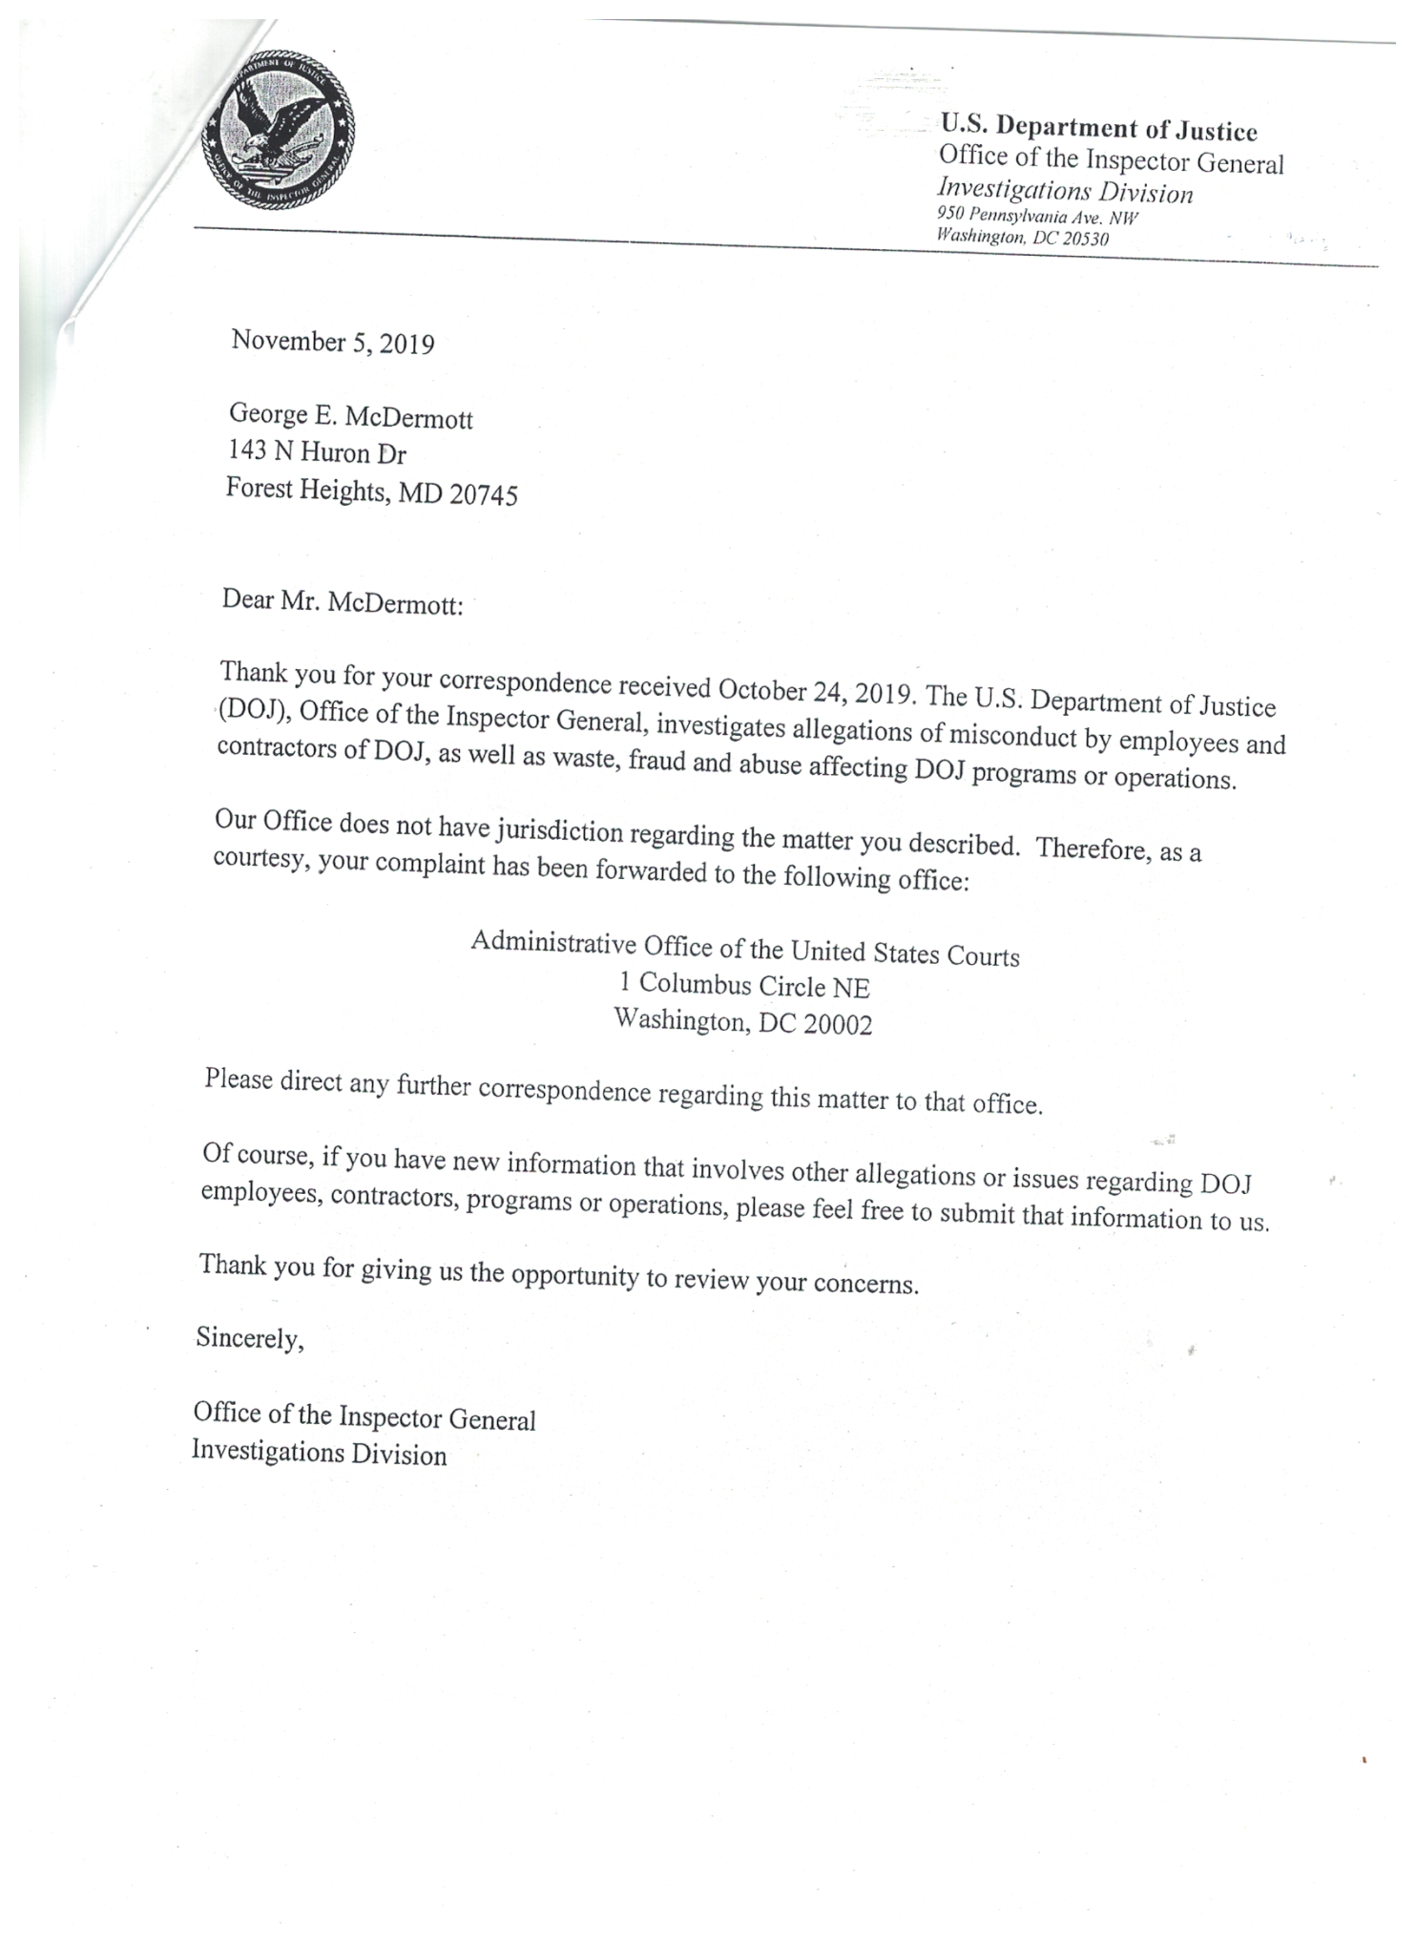
IT TAKES COURAGE FOR ONE TO STAND UP FOR ITS CONVICTIONS ANY CRIMINAL CAN ISSUE UNSIGNED UNVERIFIABLE ORDERS TO ASSIST THEIR FELLOW BAR MEMBERS IN THE THEFT OF CITIZENS PROPERTY JUST REMEMBER THAT THE REACH OF THEIR OATH OF OFFICE AND TREASON AGAINST THE CONSTITUTION AND RULE OF LAW…  Exodus 20:16 Thou Shalt Not Bear False Witness Against Thy Neighbour. | Lori Saxon And Her Daughter Jane Zirkle Saxon Have Also Been Targeted by the wrongful acts of the treaty state operating as USA Inc. and its officers and agents in the District of Columbia subsidiary Inc. state as well as the Inc. state of New Jersey there courts court agents and assigns all working in direct violation of the oath of office and bylaws by which these organizations are bound. Once again denying the victims Lori and her daughter access to the courts through false claims of lack of jurisdiction failure to prevent abusive, processes by their respective courts aiding in the theft of ½ $1,000,000 of his father and court insiders responsible for the wrongful death of the minor child’s grandfather as described in the following programs. 485,503, 508, 512, 523, 525, 532, 541, 547, 550A –C, 555,580, 581,, 603, 620, 621, 622, 626, 626 – 2, 630, 706, 707, 709, 710, 726, 727, 728, 729, 730, 731, 732, 737, 738a, 824, 847, 1009, 1031, 1032, 1059, 1061, 1062, 1063, 1064, 1065, 1066, 1067, 1068, 1069, 1070, 1073, 1074, 1089, 1090, 1104, 1105, 1108, 1136, 1149,1166, 1167, 1174, all the actions against the victims been in violation of the minimal standards of the UN international human rights tribunals laws statutes and rules which the Inc. states and their agents refused to protect required by law petitioner is also assisted this victim to prevent further miscarriage is of justice and deprivation of human rights.. Latest postings on defendant and pro se litigants including intervener 139, 1400, 1401, 1402, 1403, 1404, 1405, 1406, 1407, 1408, 1409, 1410, 1411, 1412, 1413, 1414, 1415, in every case pro se litigants rights are destroyed by courts violating the CONSTITUTION/RULE OF LAW  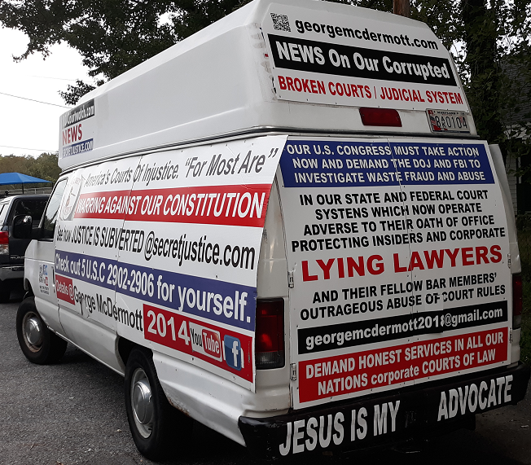
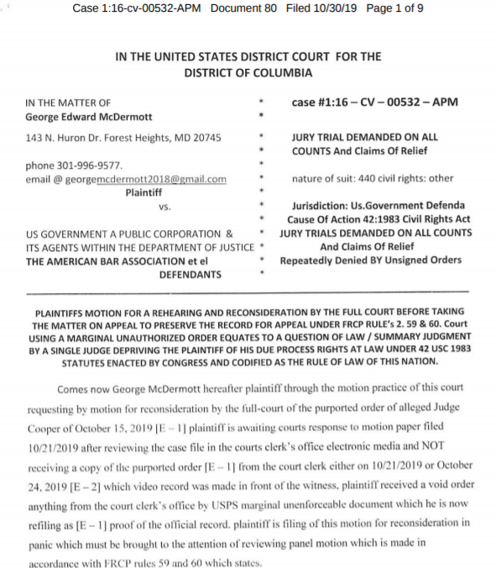
MEMORANDUM OF LAW SUPPORT OF MOTION TO INTERVENE
STATUTES REPLACED WITH INTERNATIONAL LAW CIRCA 193December 9th 1945 International Organization Immunities Act relinquished every public office of the United States to the United Nations.
http://avalon.law.yale.edu/20th_century/decad034.asp http://www.law.cornell.edu/uscode/html/uscode22/usc_sec_22_00000288—-000-notes.html
Government /Judiciary Agent Acting As An [Offshore] Statute Merchant
Treaty States Whatever the form in which the Government functions, anyone entering into an arrangement with the Government takes the risk of having accurately ascertained that he who purports to act for the Government stays within the bounds of his authority.
Additionally Treaty Defines The scope of this authority may be explicitly defined by Congress or be limited by delegated legislation, properly exercised through the rule-making power. And this is so even though, as here, the agent himself may have been unaware of the limitations upon his authority. See, e.g., Utah Power & Light Co. v. United States, 243 U.S. 389. 409, 391; United States v. Stewart, 311 U.S. 60, 70, 108, and see, Generally, In Re Floyd Acceptances, 7 Wall. 666);
This Treaty/Statute Defines Legal Responsibility On Courts That Must Be Recognized As The Rule Of LAW pursuant to Organization Immunities Act which relinquished every public office of the United States to the United Nations. Title 8 USC 1481 stated once an oath of office is taken citizenship is relinquished, thus you become a foreign entity, agency, or state. That means every public office is a foreign state, including all political subdivisions. (i.e. every single court and that courts personnel is considered a separate foreign entity) A Requirement This Court That Seems To Ignore As A Public Corporation.
December 26th 1933 49 Statute 3097 Treaty Series 881 (Convention on Rights and Duties of States) stated CONGRESS replaced STATUTES with international law, placing all states under international law. Intervener can find no place in the international law that allows this court and state courts to picking choose jurisdictional and constitutional statutes to illegally disenfranchise citizens of their rights to due process at law in violation of our national Constitution and Bill of Rights which the December 9th 1945 International Organization Immunities Act relinquished every public office of the United States to the United Nations. Appears to have done or the officers of this court acting in violation of their oath of office
22 CFR 92.12-92.31 FR Heading “Foreign Relationship” states that an oath is required to take office.
Title 8 USC 1481 Stated Once An Oath Of Office Is Taken Citizenship Is Relinquished, thus you become a foreign entity, agency, or state. That means every public office is a foreign state, including all political subdivisions. (i.e. every single court and that courts personnel is considered a separate foreign entity)
Title 22 USC (Foreign Relations and Intercourse) Chapter 11 identifies all public officials as foreign agents. Before this court to entertain intervenors and defendants motion for reconsideration the court has to answer for the record the superseding amendment to the law and to the above referenced treaty that allows this court to disrespect his legal duties and obligations under our US Constitution/Bill of Rights

Additionally The Judge Of This Court And Its Officers Are Bound By The Chains Of Our Constitution and Title 28 USC 3002 Section 15A states that the United States is a Federal Corporation and not a Government, including the Judiciary Procedural Section. For this court or any other court to issue unsigned orders with no verification or authenticity of electronic signatures each order issued by these courts as an act of treason against our Constitution and rule of law as outlined under title 18 USC 2382 and intervener is duty-bound to report this conduct to the President of the United States since no judicial officer of this so.

